 | School of Computing  Second CIA Exam – Sept 2025  Course Code: INT317  Course Name: DATA MINING AND ANALYTICS  Duration: 90 minutes Max Mark: 50
PART A
Answer any FIVE of the following questions 5x10=50
1.Find the naïve bayes probability computation on the given data for the test instance X= {Weather:” rainy”, Road condition:” Good”, Traffic:” Normal”, Engine Issue: No}.
Weather | Road Condition | Traffic | Engine Issue | Accident
Rainy | Bad | High | No | Yes
Cloudy | Average | Normal | Yes | Yes
Clear | Bad | Light | No | No
Clear | Good | Light | Yes | Yes
Cloudy | Good | Normal | No | No
Rainy | Average | Light | No | No
Rainy | Good | Normal | No | No
Cloudy | Bad | High | No | Yes
Clear | Good | High | Yes | No
Clear | Bad | High | Yes | Yes

2. We have two features of the following data points:
X1: (2.5, 1.5, 1.7, 1.9, 2.9, 2.3, 2.8,1.6)
X2: (545, 438, 489, 429, 528, 503, 563, 445)
the corresponding target values: (1, 0, 0, 0, 1, 1, 1, 0), using the K-Nearest Neighbors algorithm with k=5, determine the target value for the new data point A= (1.8,415) by calculating the Euclidean distances between A and each of the given data points.

3. Dr. Bob is developing a model to predict whether patients have cancer based on their medical data. After training the model, the results for a group of 3895 patients are summarized. out of the 3895 patients, 368 were diagnosed with cancer, and 3527 were healthy. The model correctly identified 266 patients with cancer and 3419 healthy patients. However, 102 patients with cancer were misclassified as healthy, and 108 healthy patients were incorrectly predicted to have cancer. Plot the confusion matrix and infer the performance measures of the model.

4. Describe the Generalized Linear Model (GLM) framework and explain the commonly used link functions for the following probability distributions:
i) Poisson
ii) Binomial
iii) Inverse Binomial
iv) Gamma.

5. Find the Root node of the decision tree for the following Dataset
Age | Cough | Fever | Cold | Viral Infection
Youth | High | No | No | No
Youth | High | No | Yes | No
Adult | High | No | No | Yes
Senior | Medium | No | No | Yes
Senior | Low | Yes | No | Yes
Senior | Low | Yes | Yes | No
Adult | Low | Yes | Yes | Yes
Youth | Medium | No | No | No
Youth | Low | Yes | No | Yes
Senior | Medium | Yes | No | Yes
Youth | Medium | Yes | Yes | Yes
Adult | Medium | No | Yes | Yes
Adult | High | Yes | No | Yes
Senior | Medium | No | Yes | No

6. Describe the iterative methods used in Nonlinear Least Squares (NLS) estimation, specifically:
i) Grid Search
ii) Newton–Raphson Method
iii) Steepest Descent Method
iv) Marquardt’s Method.

School of Computing
Second CIA Exam – Sept 2025
Course Code: INT317
Course Name: DATA MINING AND ANALYTICS
Duration: 90 minutes Max Mark: 50
PART A
Answer any FIVE of the following questions 5x10=50
1.Find the naïve bayes probability computation on the given data for the test instance X= {Weather:” rainy”, Road condition:” Good”, Traffic:” Normal”, Engine Issue: No}.
Weather | Road Condition | Traffic | Engine Issue | Accident
Rainy | Bad | High | No | Yes
Cloudy | Average | Normal | Yes | Yes
Clear | Bad | Light | No | No
Clear | Good | Light | Yes | Yes
Cloudy | Good | Normal | No | No
Rainy | Average | Light | No | No
Rainy | Good | Normal | No | No
Cloudy | Bad | High | No | Yes
Clear | Good | High | Yes | No
Clear | Bad | High | Yes | Yes
Answer:
Naïve Bayes Classification problem (10 Marks)
X= {Weather:” rainy”, Road condition:” Good”, Traffic:” Normal”, Engine Issue: No} The Value of Yes = 0.0016 and No= 0.0192 therefore No Accident.

2. We have two features of the following data points:
X1: (2.5, 1.5, 1.7, 1.9, 2.9, 2.3, 2.8,1.6)
X2: (545, 438, 489, 429, 528, 503, 563, 445)
the corresponding target values: (1, 0, 0, 0, 1, 1, 1, 0), using the K-Nearest Neighbors algorithm with k=5, determine the target value for the new data point A= (1.8,415) by calculating the Euclidean distances between A and each of the given data points.
Answer:
Distance Calculation (8 Marks)
d (A, X1) = 130.003, d (A, X2) = 22.992, d(A,X3) = 74.00, d(A,X4) = 14.001,
d (A,X5)= 113.005, d (A,X6) = 88.001, d(A,X7)= 148.003, d(A,X8)= 30.001
The 5 nearest neighbors (smallest distances) are: (2 Marks)
- X4 with distance 14.00114.00114.001 (Target: 0)
- X2 with distance 22.99222.99222.992 (Target: 0)
- X8 with distance 30.00130.00130.001 (Target: 0)
- X3 with distance 74.00074.00074.000 (Target: 0)
- X6 with distance 88.00188.00188.001 (Target: 1)
The Predicted target of new data point A(1.8,415) is 0.

3. Dr. Bob is developing a model to predict whether patients have cancer based on their medical data. After training the model, the results for a group of 3895 patients are summarized. out of the 3895 patients, 368 were diagnosed with cancer, and 3527 were healthy. The model correctly identified 266 patients with cancer and 3419 healthy patients. However, 102 patients with cancer were misclassified as healthy, and 108 healthy patients were incorrectly predicted to have cancer. Plot the confusion matrix and infer the performance measures of the model.
Answer:
Confusion Matrix (2 Marks)
Accuracy = 94.61 % (2 Marks)
Precision = 71.12 % (2 Marks)
Recall= 72.28% (2 Marks)
F1Score=71.70 % (2 Marks)

4. Describe the Generalized Linear Model (GLM) framework and explain the commonly used link functions for the following probability distributions:
i) Poisson
ii) Binomial
iii) Inverse Binomial
iv) Gamma.
Answer:
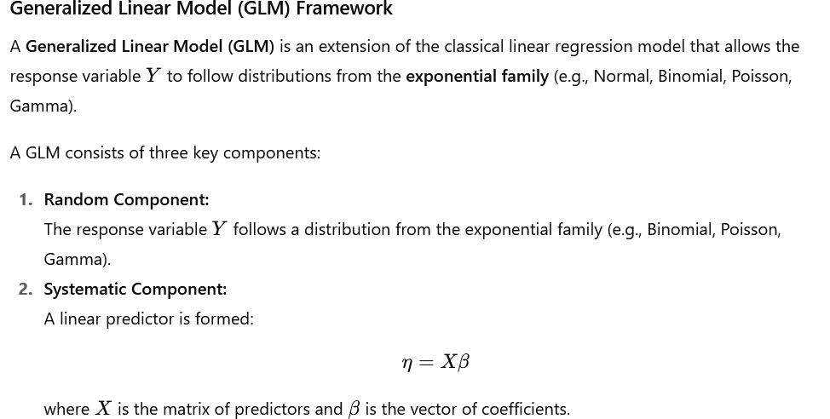
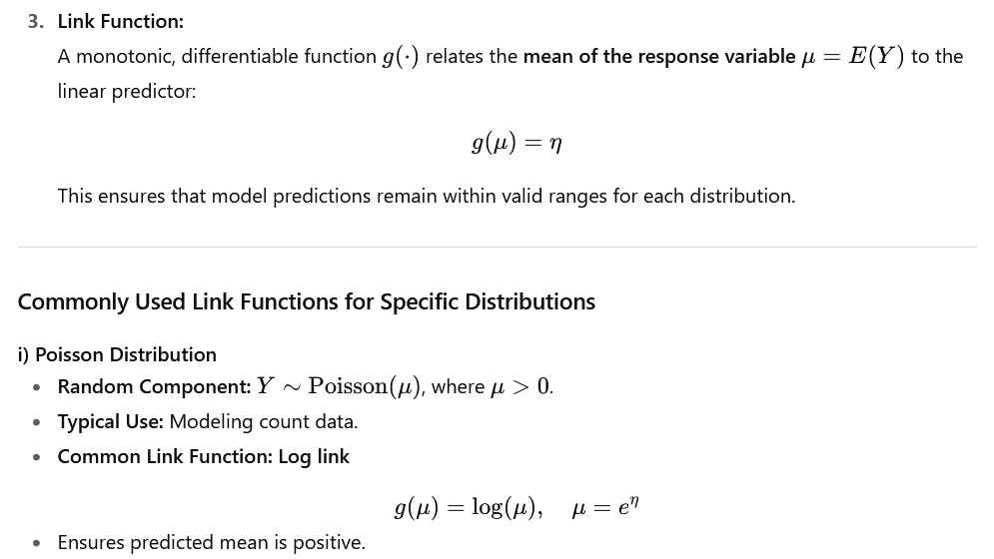
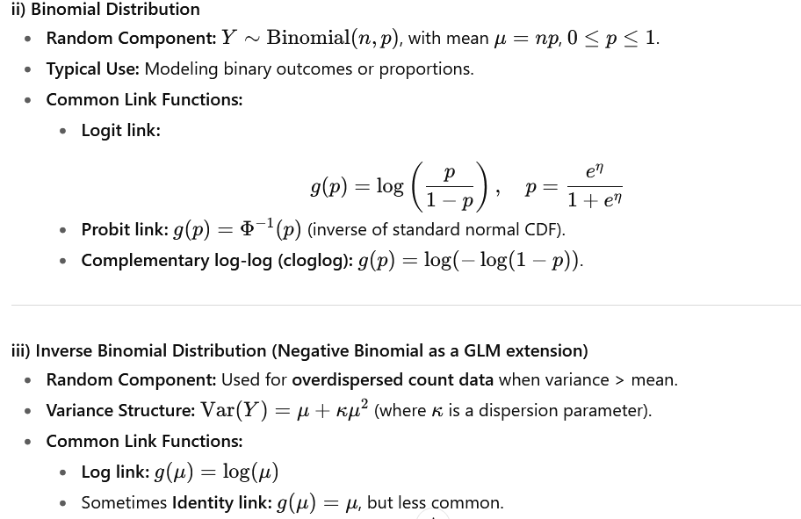
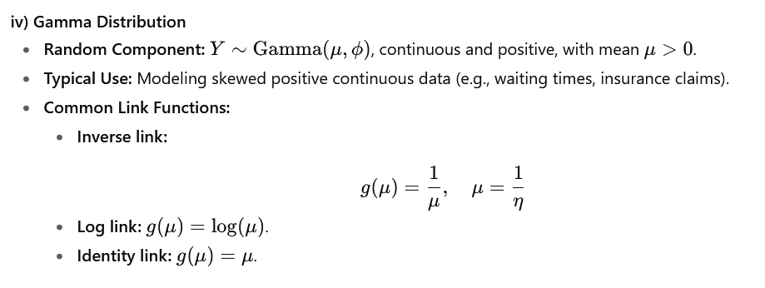

5. Find the Root node of the decision tree for the following Dataset
Age | Cough | Fever | Cold | Viral Infection
Youth | High | No | No | No
Youth | High | No | Yes | No
Adult | High | No | No | Yes
Senior | Medium | No | No | Yes
Senior | Low | Yes | No | Yes
Senior | Low | Yes | Yes | No
Adult | Low | Yes | Yes | Yes
Youth | Medium | No | No | No
Youth | Low | Yes | No | Yes
Senior | Medium | Yes | No | Yes
Youth | Medium | Yes | Yes | Yes
Adult | Medium | No | Yes | Yes
Adult | High | Yes | No | Yes
Senior | Medium | No | Yes | No
Answer:
Information Gains for each attribute:
- Age: 0.246750
- Cough: 0.029223
- Fever: 0.151835
- Cold: 0.048127
Age is the root node

6. Describe the iterative methods used in Nonlinear Least Squares (NLS) estimation, specifically:
i) Grid Search
ii) Newton–Raphson Method
iii) Steepest Descent Method
iv) Marquardt’s Method.
Answer:
